**IMPORTANCE OF ROUTINES**

Children succeed in a well-ordered and predictable environment, where daily routines such as arrivals and departures, mealtimes, nap times and toileting are dealt with consistently by all caregivers. Daily routines provide opportunities for children to learn more about themselves, the world and other people. Daily routines also offer children a sense of stability, and a feeling of warmth and caring from their teachers. The challenge is to develop appropriate daily routines for children which offer them a sense of consistency and security, yet remain flexible and responsive to the individual needs of each child.

**Daily Schedule**

In order to establish daily routines, most preschool virtual classrooms follow a basic daily schedule. Among other things, a schedule can help to ensure the consistency that young children need and also help teachers encourage all areas of development by planning a wide range of activities. It's helpful to think of a daily schedule as a guide which is responsive to children and teachers. In creating schedules, it is also important to provide a healthy balance for children, between group times and more solitary moments, quiet and noisy activities, indoor and outdoor play.

**Transitions**

Transition times are important because they can make the day seem smooth and well-organized, or rushed and unpleasant. Allowing enough time so children make the transition gradually is the best way to avoid stressful situations. In addition to allowing a realistic amount of time for transitions to take place, it always helps to warn once in advance before a change in activities. This gives the children a chance to finish what they are doing and their cooperation is more likely. It might also help move the process along if we comment favorably about the next activity and avoid situations where all the children are expected to do the same thing at the same time.

**SAMPLE OF A ROUTINE AT HOME**

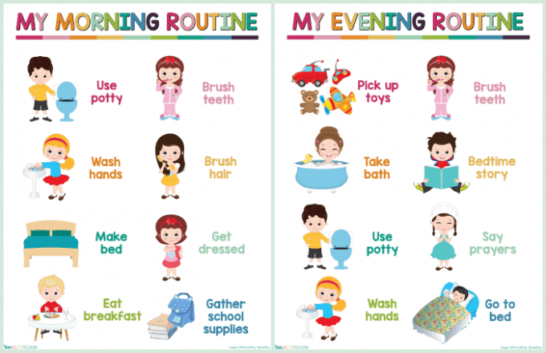

*For your child’s school day, follow the teacher’s daily schedule.

|  |  |
| --- | --- |
| **Time** | **Activity** |
| 8:30 am to 9:00 am | Breakfast time preparation/set up for the start of the school day (be sure that all technology is charged up and that materials and supplies for the day are ready in advance) |
| 9:00 am to 10:00 am | Greeting Time – live instruction  Message Time – live instruction  Read Aloud – live instruction (story, discussion, questions)  (children will have a 5 min brain break) |
| 10:00 am to 11:00 am | Outside Time/Work Time (flexibility):  Children can work independently on assigned tasks  Children can engage in hands on activities and creative arts (i.e. painting, finger painting, drawing, playdough, collaging)  Children can develop their large muscles by going outside or to the park to run, jump, play ball, ride a tricycle, etc.  Children can engage in mindfulness strategies, yoga, and stress release activities |
| 11:00 am to 12:00 pm | Large Group Time: music and movement, songs, nursery rhymes, dance, etc.  Small Group Time (teacher and para will break up into two small instructional groups):  Monday – English Language Arts (ELA)  Tuesday – Math  Thursday – Science  Friday – Social Emotional Learning (SEL)  (children will have a 5 min brain break) |
| 12:00 pm to 1:30 pm | Lunch/Nap Time for Children |
| 1:30 pm to 3:00 pm | Outside Time/Work Time (flexibility):  Children can work independently on assigned tasks  Children can engage in hands on activities and creative arts (i.e. painting, finger painting, drawing, playdough, collaging)  Children can develop their large muscles by going outside or to the park to run, jump, play ball, ride a tricycle, etc.  Children can engage in mindfulness strategies, yoga, and stress  release activities  Teachers are available to meet and to provide extra support to children as necessary |